**Name : خالد محمد أحمد عبدالله**

**B.N: 318**

**Date :**

**Topic:** **Internet of Things**

**Github link : https://khaliedmuhamad.github.io/ECE006/**

**Github page :** [**https://github.com/khaliedmuhamad/ECE006**](https://github.com/khaliedmuhamad/ECE006)

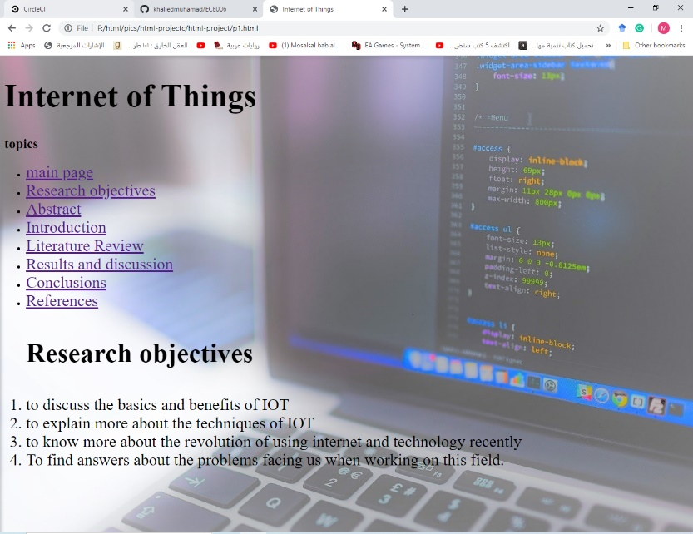**Screen shots:**

